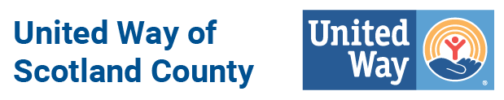

Glossary of Terms
We understand that we use terms that may be unfamiliar and confusing! Here is a breakdown of some common terms you may hear during campaign season.

Average Gift – Total employee contributions divided by total number of donors in an organization
Community Impact Fund - United Way’s Community Impact Fund is comprised of all unrestricted donor gifts. These funds are split between all of our approved Partner Agencies who provide services that have a direct impact on the Scotland County Community.
Designations – Donations that a supporter directs to a specific United Way Community Partner Agency.
Partner Agencies – Non-Profit Agencies that provide a service to Scotland County, who have been approved through our rigorous application process.
Payroll Deduction – Often abbreviated PRD, the amount withheld by an employer from an employee’s earnings as determined by the employee’s United Way pledge card.
Per Capita Giving – Total employee contributions divided by total number of employees.
Unrestricted Giving – When a donor does not designate their gift to any one specific United Way Partner Agency. Instead the gift goes into the Community Impact Fund and distributed to all of our approved Partner Agencies.
Restricted Giving – When a donor designated their gift to one or several of our United Way Community Partner Agencies.

